**How Is Title Insurance Used in Commercial Real Estate?**

* [By atlantistitle](https://anstitle.com/author/atlantistitle/)
* [/ April 18, 2022](https://anstitle.com/2022/04/18/)



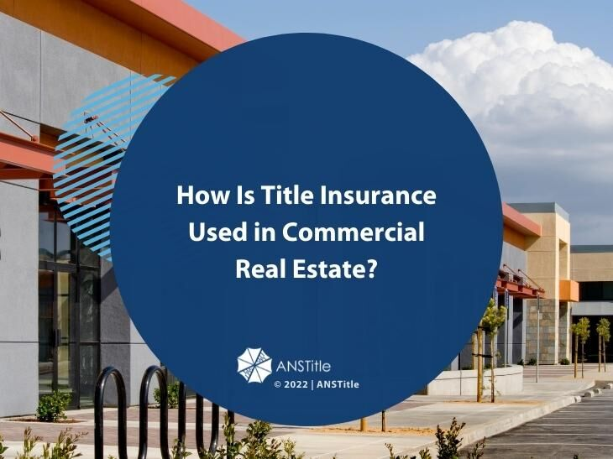

The purpose of title insurance in commercial real estate transactions is not much different than in residential purchases. It is meant to protect the buyer and their mortgage lender from losing money as a result of previously unknown issues with the property title.

Yet, having [title insurance](https://anstitle.com/understanding-title-insurance/) on your commercial property is much more critical than having a policy for your home. In this article, ANSTitle reviews some of the reasons why insuring your commercial building is a must. We’ll also explain how title insurance works, how it can protect the commercial property owner, and how much it costs.

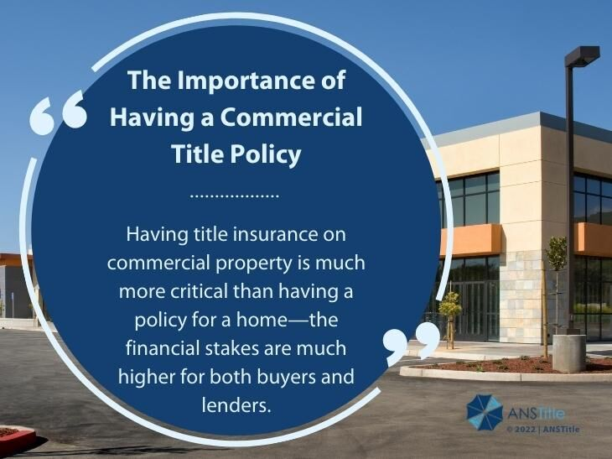

**The Importance of Having a Commercial Title Policy**

Commercial real estate is much more expensive than single-family homes, condos, and other residential buildings. Therefore the financial stakes are much higher for both buyers and lenders. An unpaid lien or an unresolved ownership claim on an office building or a shopping center worth several million dollars can end up costing hundreds of thousands of dollars in mitigation costs.

Furthermore, commercial properties tend to change ownership more often than residential real estate. The more times a property changes hands, the more chances for title issues to occur. For one, ownership of commercial properties is a lot more complicated. Oftentimes, the owner is an LLC that is owned by other LLCs, a corporation, or several individuals. Unresolved ownership claims are much easier to arise when there are multiple levels of ownership.

[Commercial buildings](https://anstitle.com/the-importance-of-title-insurance-when-buying-a-home-or-a-commercial-building/) also require much more stringent property management than residential properties. HVAC servicing contracts, roof repairs, janitorial and landscaping services, and space buildouts are just a few examples of standard maintenance at a typical office or warehouse building. If left unpaid, such expenses can result in future liens against the property and an unsuspecting new owner.

Next, we’ll explain how title insurance works in protecting commercial property buyers and lenders from unforeseen financial losses.

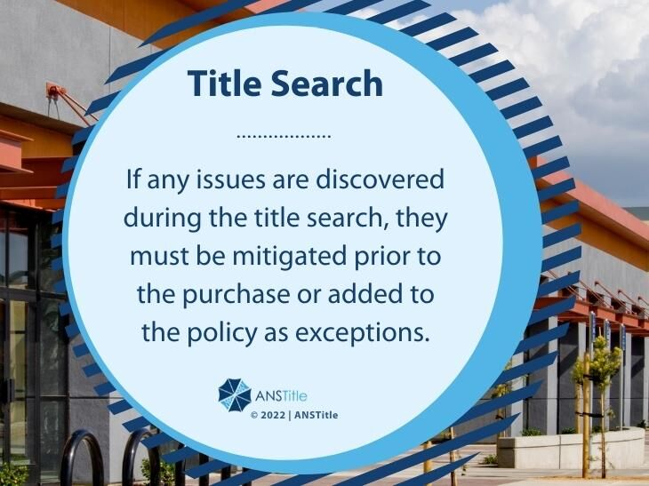

**Understanding Title Insurance**

When purchasing title insurance, a commercial real estate buyer insures themselves against a number of possible issues that may exist with the property they are looking to buy. Unlike other insurance policies, which are meant to protect you from mishaps that may take place in the future, title insurance only covers events that have already happened. This means that the current owner cannot use their title insurance to resolve issues that occurred during their ownership. For example, if you skip on paying property taxes and the local tax authority places a lien on your property, don’t expect your title policy to fix this.

**Title Policy Types**

There are two types of title insurance policies for commercial properties – an owner’s policy for the buyer and a lender’s policy for the mortgagee. The basic coverage of both policy types is similar. While the owner’s policy remains in effect for as long as the policyholder owns the property, the lender’s policy is only active for the duration of the loan term. Once the property gets sold, both policies are terminated.

**Title Search**

Prior to issuing a policy, the insurance agent will conduct a title search in an effort to discover any claims, liens, or boundary issues with the property. If any issues are discovered, they would need to be mitigated prior to the purchase or added to the policy as exceptions. The title company has a big stake in discovering anything wrong with the property as they will be underwriting a title insurance policy for it. If a claim is discovered in the future, the title insurance company will be responsible for resolving the issue and covering the expenses associated with it.

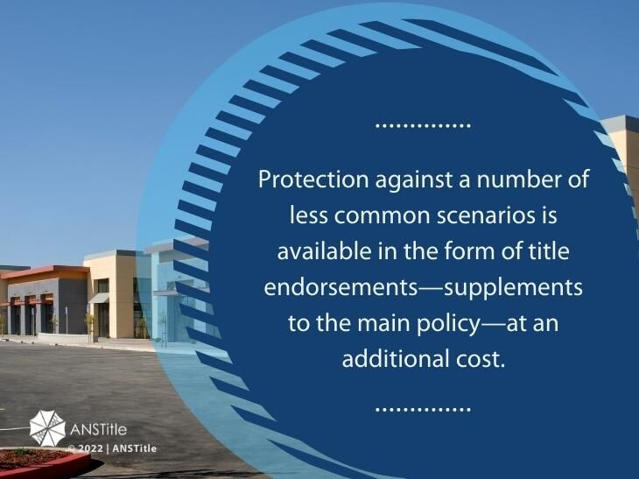

**Claim Coverage**

Title insurance policies are uniquely drafted to the specific circumstances of each commercial property and transaction. There are, however, several common issues that are covered by most policies. These include:

* **outstanding property taxes** – unpaid taxes by past property owners;
* **easements** – issues with access to the property;
* **encroachments** – improperly placed fencing, neighboring buildings, or other fixtures;
* **contractor’s liens** – unpaid bills for work or maintenance done to the property;
* **unknown owners** – issues arising from third parties claiming ownership;
* **boundary issues** – disputes around the proper boundaries of the lot;
* **incorrect or forged records**– issues with the validity of the deed or other official documents;
* **building code violations**– any improvements or construction done in violation of the local building code;
* [**survey errors**](https://info.courthousedirect.com/blog/common-surveying-mistakes-and-how-to-fix-them)– disputes caused by incorrect surveying of the property.

Title insurance companies also offer protection against a number of less common scenarios in the form of [title endorsements](https://anstitle.com/title-endorsements-what-are-your-options/). Endorsements are meant to supplement the main policy by providing coverage for less common issues specific to the property in question and they have an additional cost.

**Title Insurance Pricing**

Title insurance rates are typically tiered by the amount of coverage needed, which is also the mortgage loan amount. For example, the title insurance cost in NY State for a loan of up to $35,000 is $338 for an owner’s policy and $284 for a loan policy. The next tier of up to $50,000 of coverage costs an additional $7.52 and $6.28 per $1k, respectively, and so forth. There are also bundle rates for those purchasing both policies, which on average would be about 0.5% to 1% of the commercial property purchase price.

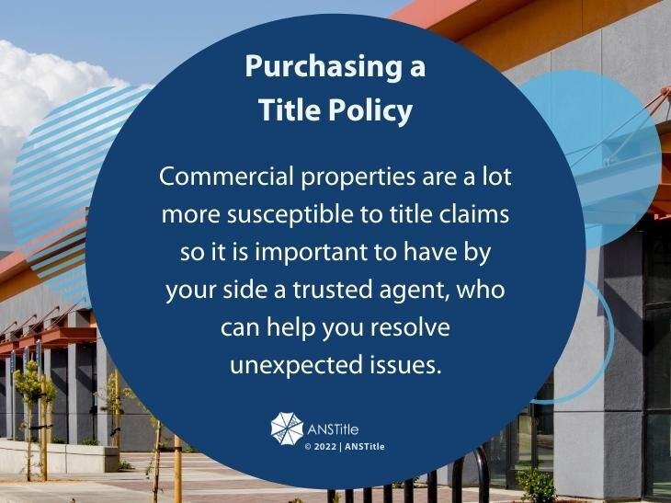

**Purchasing a Title Policy**

Title insurance pricing is regulated in most states so every legitimate agent in that state will offer you the same title insurance quote. In New York State, for example, the rates are set by the [Title Insurance Rate Service Association (TIRSA)](https://www.tirsa.org/) and approved by the Department of Financial Services. Similarly, in New Jersey, the New Jersey Land Title Insurance Rating Bureau prepares the rates, which are then approved by the state’s Commissioner of Banking and Finance.

Since pricing won’t be a factor in selecting an agent, you need to focus on finding a title insurance company with a good reputation and experience. Commercial properties are a lot more susceptible to title claims so it is important to have by your side a trusted agent, who can help you resolve unexpected issues.

Whether you need a title insurance quote for a residential or commercial property, [give one of our agents a call](https://anstitle.com/contact-us/). ANSTitle is a New York-based title insurance company with over 50 years of experience in the industry. In addition to title insurance policies and lien searches, we offer settlement, escrow, recording, and 1031 Exchange services. While we serve customers primarily in New York and New Jersey, we can conduct closings in all 50 states.